2.5. I/O System and Memory:

In this part, we implement a Load-Store Unit (LSU) which functions as an I/O System and Memory. The LSU includes 5 main components: Decoder, Input_Buffer, Output_Buffer and Data_Memory that present in Figure 1.

Figure 1: LSU Diagram.

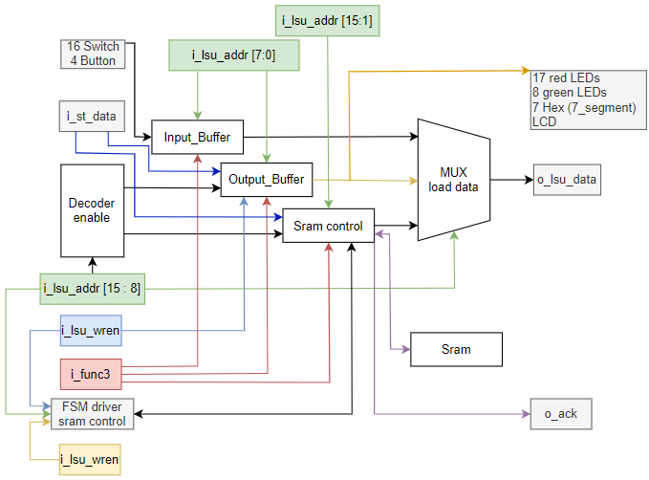

LSU’s address is range 0x2000 to 0x781F, which represented in 16 bits, but i_lsu_data represented in 32 bits (4 byte). We only use 2 byte low of LSU address and don’t care the other.

DECODER: base on i_lsu_adder [15 : 8] (second byte) to select the store region (Output_buffer and Data_Memory).

MUX: base on i_lsu_adder [15 : 8] (second byte) to select the load region.

*I/O System

The proccessor interacts with environment through Input_Buffer and Output_Buffer.

Input_Buffer and Output_Buffer is implemented as 8-bit register array (similar to Instruction Memory).

Input_Buffer: contains value of Switch and Button Signal. When we interact with Switch and Button that reflected in the region of Input_Buffer (the address of register). It’s address is in range 0x7800 to 0x781F. The Input_Buffer is implemented as 32 x 8 bit-registers (32 byte). Because we use the second byte to select region of LSU, we just use the first byte as address for interact with Input_Buffer. We can’t store data in Input_Buffer, only load the data from Input_Buffer.

Output_Buffer: is connected to the red LEDs, green LEDs, 7-segment displays and LCD1602. It’s address is in range 0x7000 to 0x703F. The Output_Buffer is implemented as 64 x 8 bit-registers (64 byte). Similar to Input_Buffer, we just use the first byte as address for interact with Out_Buffer. We can load or store data in Output_Buffer.

*Memory

The Data_Memory is used to store data and load it out when needed. It’s address is in range 0x2000 to 0x3FFF. In this implementation, we use sram IS61WV25616 replace for Data_Memory.

We use the sram_control module which is provided.

According to the datasheet, this sram is 2 bytes data width corresponding to an address. We need to adjust the LSU’s address that fit to sram’s address. Solution is shift right LSU’s address one bit, we have sram’s address. Because one LSU’s address can be stored address, but one sram’s address can be stored two byte data. So the LSU’s address is “double” than the sram’s address.

Sram has 18 bits address width, we just use 15 bit low to control sram. So 3 bit high set to zero.

To driver this module, we design a combination logic for driver BMASK and store data by func_3 (sw, sb, sh, lw, lb, lbu, lh, lhu) and a ASM for driver WREN and RDEN that is present in Figure 2.

Figure 2: FSM Driver Sram Control.

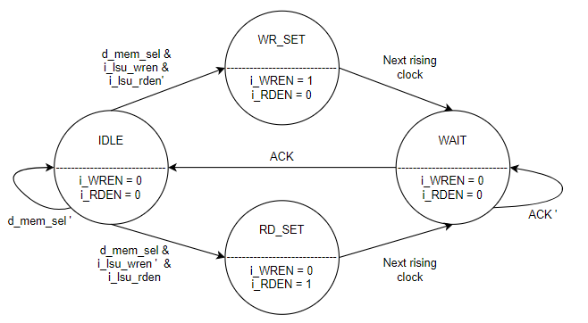

Because the operation delay 2 cycle for write and 5 cycle for read, we need to hold the PC value, wait for the operation completely. Solution is design a combinational logic that can stop PC update next value after each cycle which present in Figure 3.

Figure 3: Combinational logic of control program counter.

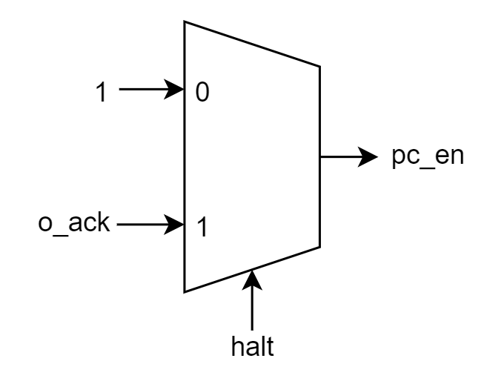

The halt signal is active when meet these condition: Opcode is of R-format layout (Store) or I-format load and i_lsu_adder in Data_Memory’s address range.

The ack signal is feelback signal of sram control module. When it’s active means the operation completely and allow PC update next value.

2.5.1 Specification

|  |  |  |  |
| --- | --- | --- | --- |
| **Signal** | **Width** | **Direction** | **Description** |
| i_clk  i_rst_n  i_lsu_addr  i_st_data  i_lsu_wren  i_func_3  o_ld_data  o_io_ledr  o_io_ledg  o_io_hex0…7  o_io_lcd  i_io_sw  i_io_btn  o_ack  SRAM_ADDR  SRAM_DQ  SRAM_CE_N  SRAM_WE_N  SRAM_LB_N  SRAM_UB_N  SRAM_OE_N | 1  1  32  32  1  3  32  32  32  7  32  32  4  1  18  16  1  1  1  1  1 | input  input  input  input  input  input  output  output  output  output  output  input  input  output  output  inout  output  output  output  output  output | Globa clock, active on the rising edge.  Globa low active reset.  Address for data read or write.  Data to be store.  Write enable signal (1 if writting).  Select function sw, sb, sh, lw, lb, lbu, lh, lhu.  Data read from memory.  Output for red LEDs.  Output for green LEDs.  Output for 7-segment displays.  Output for the LCD register.  Input for switch.  Input for button.  Signal to pc_halt_by_sram  SRAM address  SRAM data bus  SRAM chip enable (active-low)  SRAM write enable (active-low)  SRAM output enable (active-low)  SRAM lower byte enable (active-low)  SRAM upper byte enable (active-low) |

3.4. I/O System and Memory: